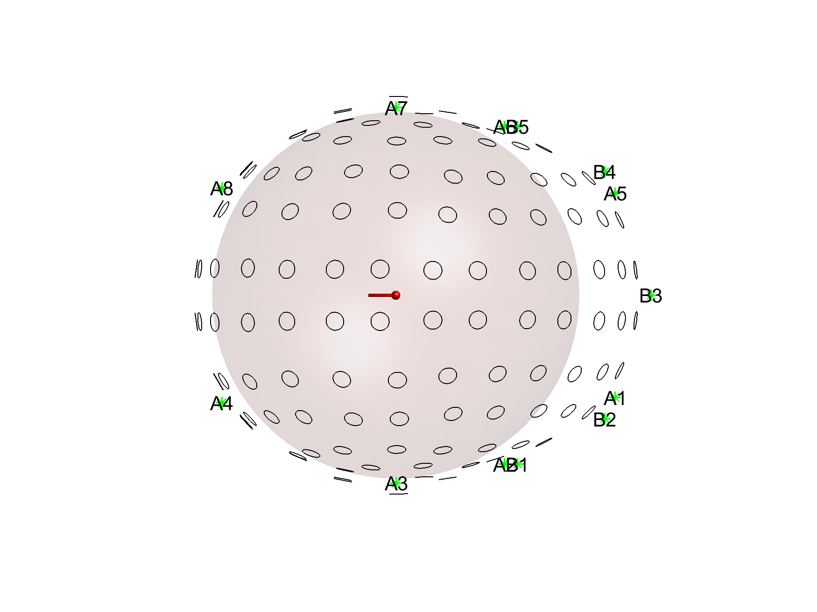

**A)**

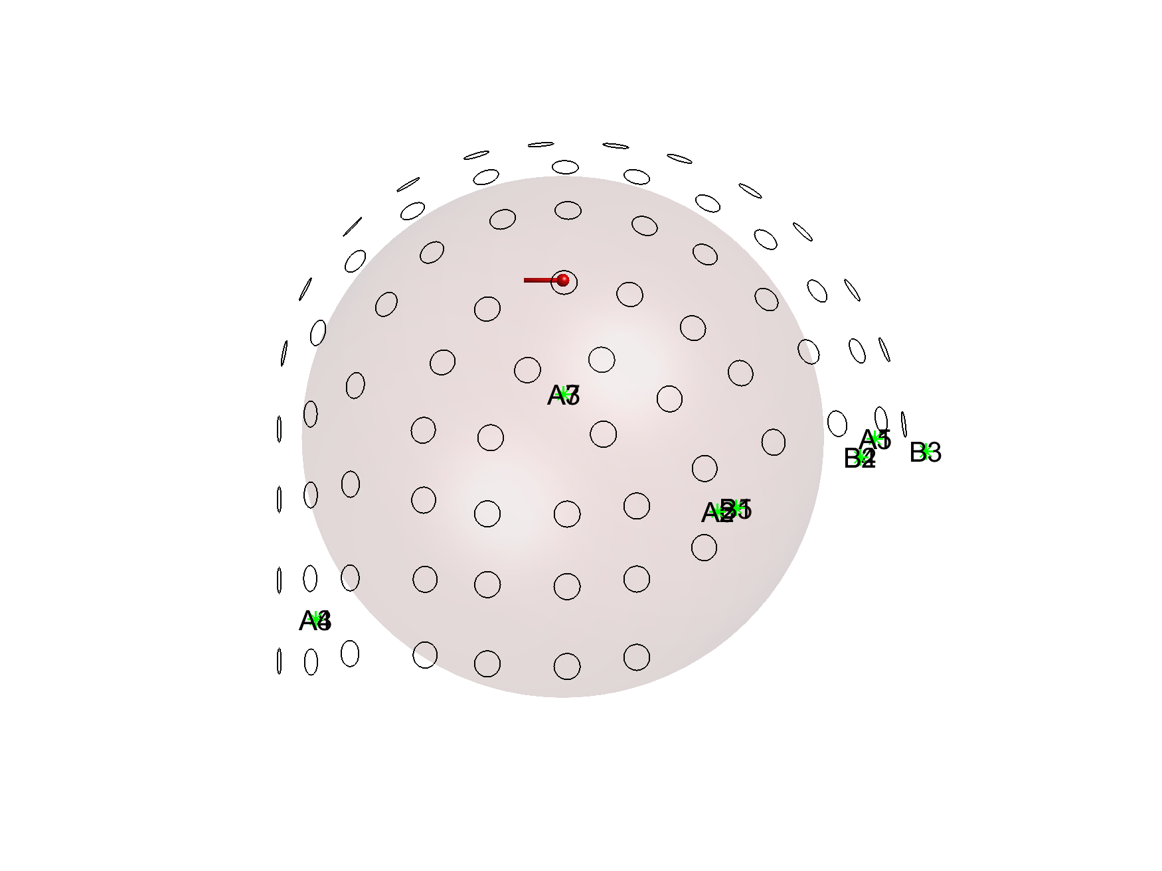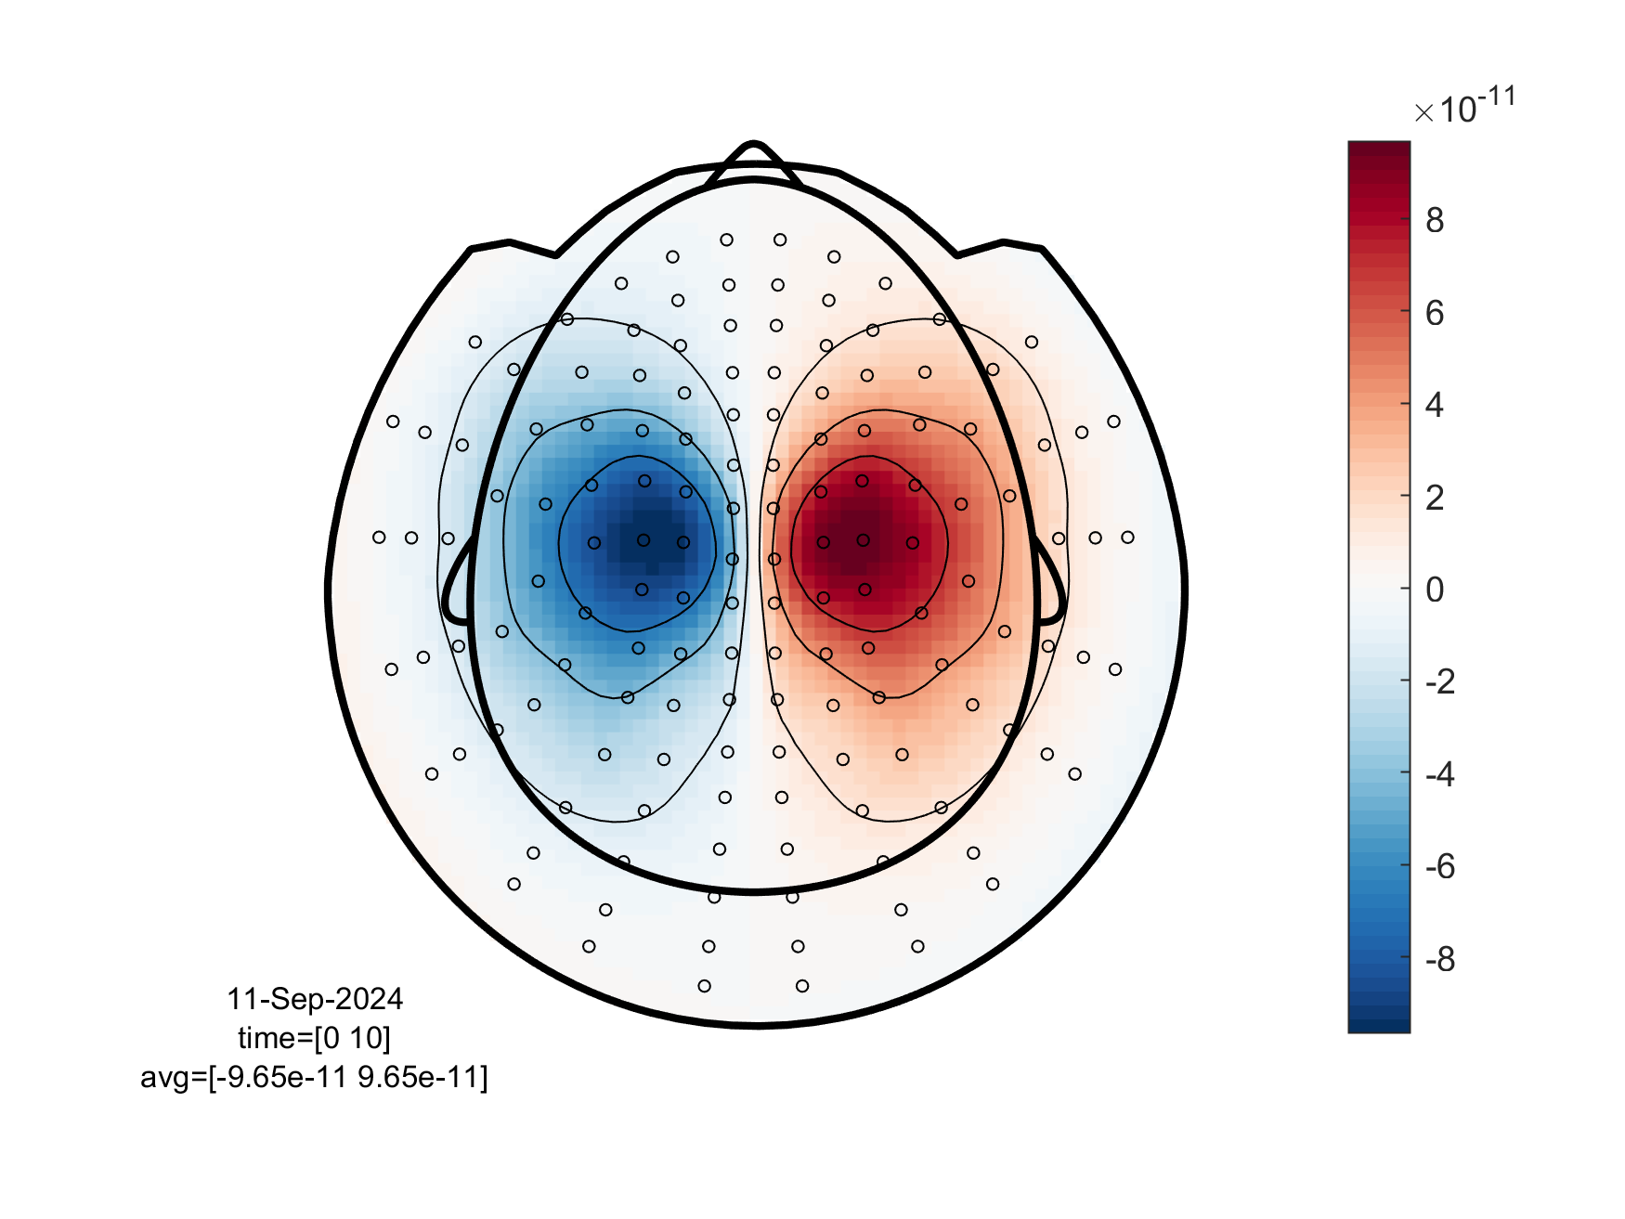

T

**B)**

**Figure A1. Effect of sensor location on source reconstruction accuracy.** A. Simple simulation using a single sphere volume conduction model. Data are simulated from a single dipole placed in the center of the head (dipole position is [0, 0, 60] mm) and oriented towards the posterior of the head (dipole moment is [0, -0.01, 0] A * m). The FieldLine OPM system (Boulder, Colorado) which has 144 radially-oriented OPM sensors is also depicted. B. Field patterns as recorded with the FieldLine OPM system. Yellow sensors are closer to the peaks of the dipolar pattern, leading to a rapid decrease of dipole moment uncertainty (DMU). Green sensors capture better the gradients of the dipolar pattern (i.e., areas around the peaks), resulting in a rapid decrease dipole position uncertainty (DPU).

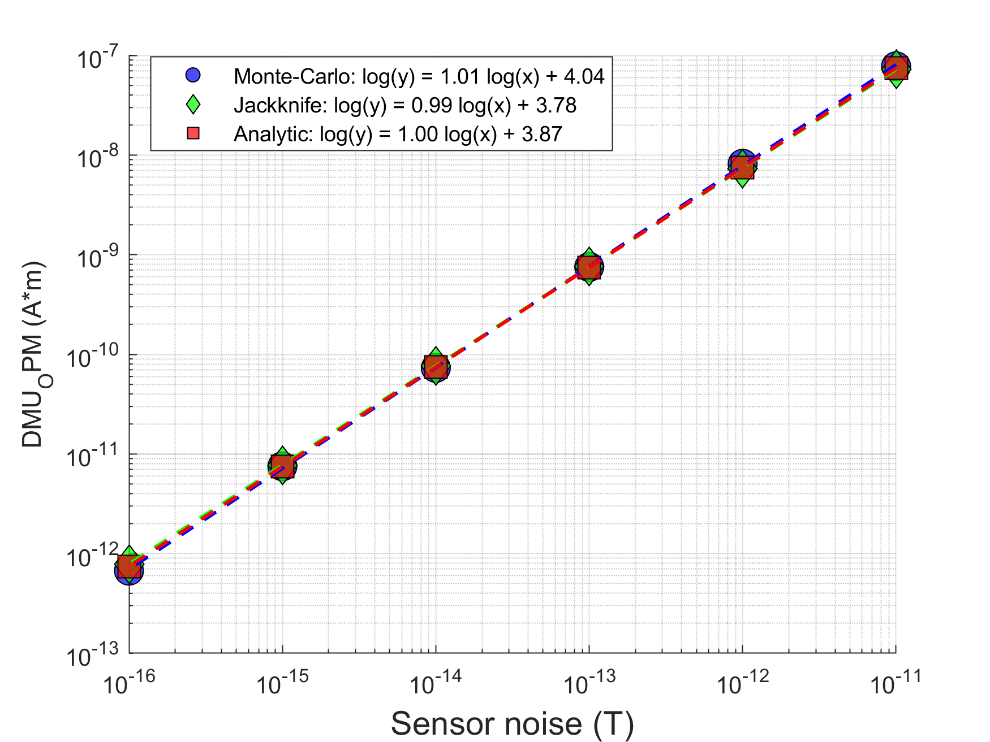

**Figure A1. Analytic solution, jackknife resampling and Monte Carlo simulations.** The dipole moment uncertainty (DMU) for the OPMs is plotted as a function of Gaussian sensor noise. The analytic solution (red squares), jackknife resampling (green diamonds), and Monte Carlo simulations (blue circles) yield the same DMU values across different noise levels. Hence, these three methods are directly comparable and can be used interchangeably. A line is fitted to each set of points. For the jackknife resampling (green diamonds), and Monte Carlo simulations (blue circles) this fitted line has slope of 1, confirming our analytic solution that DMU and sensor noise are proportianal, as shown in Section 2.5.1, Eq. (8).